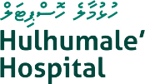
Hulhumale’ Hospital
Huvan‘dhu Maa Hingun, Hulhumale’, Republic of Maldives
bureau@hmh.mv | (960) 335 00037

Date:

TO WHOM IT MAY CONCERN

